Name : N.sai Charan
Reg no : 192372188
Course code : ECA1408

Experiment: 24
MODELING CLOCK-DRIVEN CONCURRENT PROCESSES USING SC_THREAD AND WAIT() IN SYSTEMC

AIM:
To understand and implement a clock-driven process using:
• sc_clock
• SC_THREAD
• wait()
• Event sensitivity (positive edge trigger)
in SystemC.

PROGRAM:
#include <systemc.h>

SC_MODULE(ClockExample) {
sc_in<bool> clk;

void process() {
while (true) {
wait();
std::cout << "Time: " << sc_time_stamp()
<< " - Clock Triggered" << std::endl;
}
}

SC_CTOR(ClockExample) {
SC_THREAD(process);
sensitive << clk.pos();

}
};

int sc_main(int argc, char* argv[]) {

sc_clock clock("clock", 1, SC_NS);

ClockExample module("module");
module.clk(clock);

sc_start(5, SC_NS);

return 0;
}
Output:
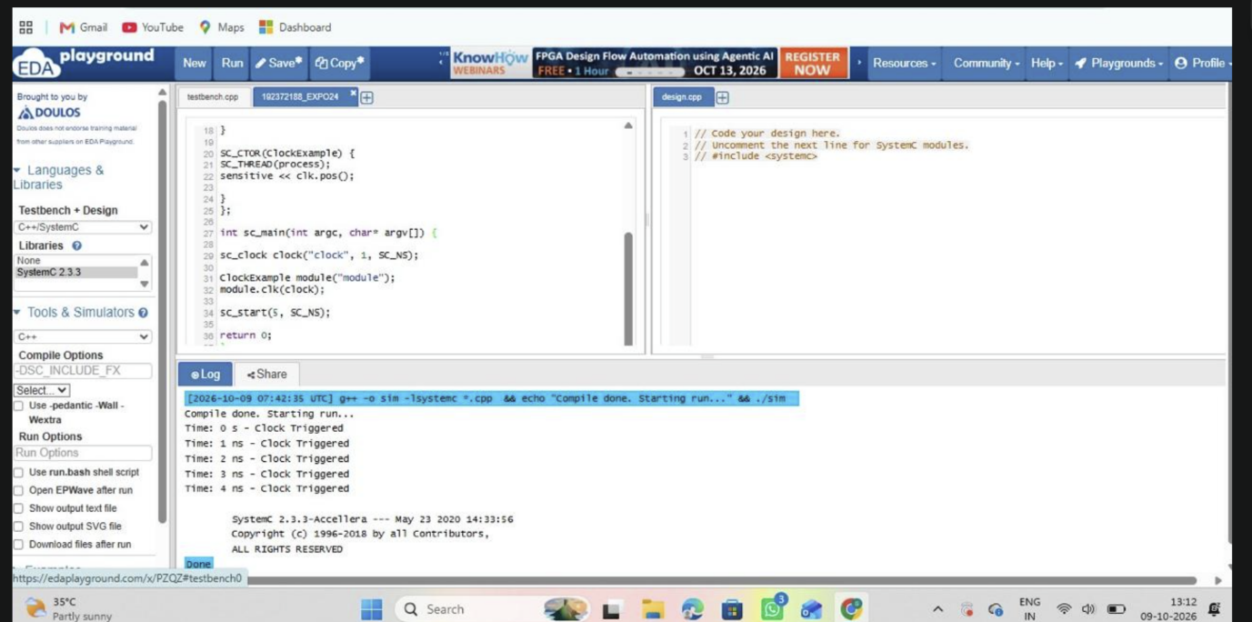

Result:
Thus, the clock-driven process using SC_THREAD and wait() was successfully
implemented and verified in SystemC.

Experiment : 25
PRODUCER–CONSUMER PROBLEM USING SYSTEMC

AIM:
To implement and simulate the Producer–Consumer problem using SystemC.

PROGRAM:
#include <systemc.h>

// Producer Module
SC_MODULE(Producer) {
sc_fifo_out<int> out;

void produce() {
for (int i = 1; i <= 5; i++) {
cout << "Produced: " << i << endl;
out.write(i);
wait(1, SC_SEC);

}
}

SC_CTOR(Producer) {
SC_THREAD(produce);
}
};

// Consumer Module
SC_MODULE(Consumer) {
sc_fifo_in<int> in;

void consume() {
int value;
while (true) {
in.read(value);
cout << "Consumed: " << value << endl;
wait(1, SC_SEC);
}
}

SC_CTOR(Consumer) {
SC_THREAD(consume);
}
};

int sc_main(int argc, char* argv[]) {
sc_fifo<int> fifo(5);

Producer producer("Producer");
Consumer consumer("Consumer");

producer.out(fifo);
consumer.in(fifo);

sc_start(10, SC_SEC);

return 0;
}

Output:
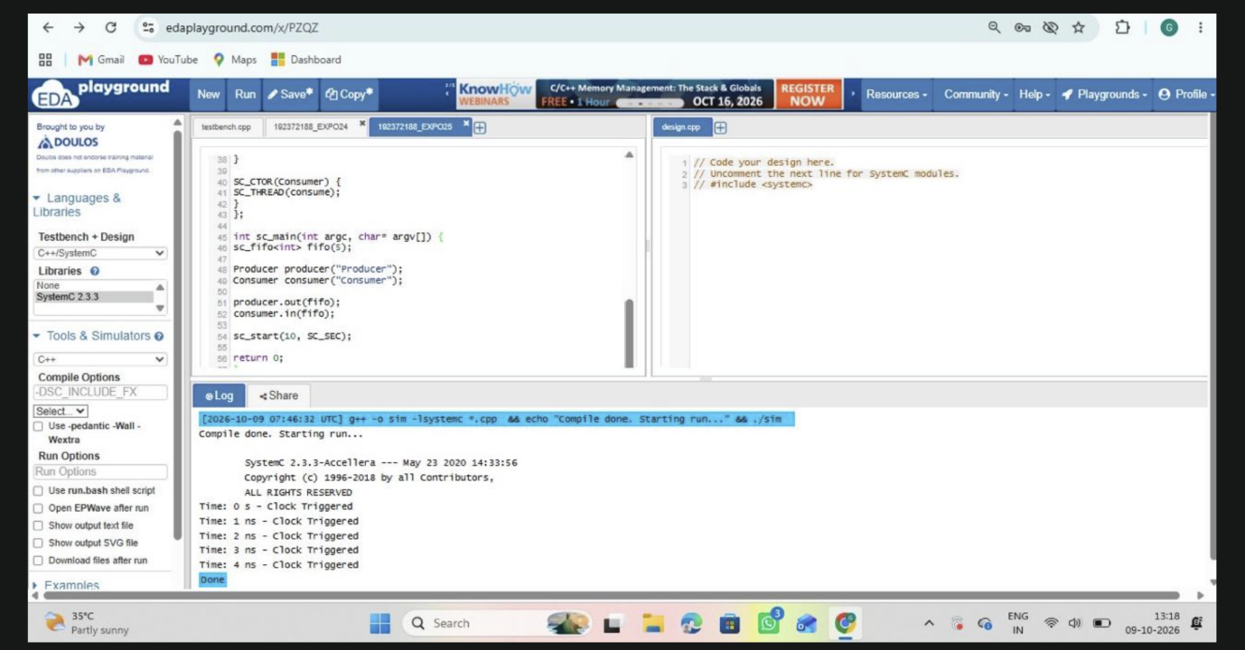

RESULT:
Thus, the Producer–Consumer problem was successfully implemented and simulated
using SystemC. Proper synchronization between concurrent processes was achieved using
FIFO communication.

Expirement : 26
TRANSACTION LEVEL MODELING (TLM) USING SYSTEMC
AIM:
To model and simulate a simple Transaction-Level Model (TLM) using Initiator and
Target modules in SystemC.

PROGRAM:
#include <systemc>
#include <tlm>
#include <tlm_utils/simple_initiator_socket.h>
#include <tlm_utils/simple_target_socket.h>

using namespace sc_core;
using namespace tlm;
using namespace std;

// Target
struct Target : sc_module {
tlm_utils::simple_target_socket<Target> socket;

SC_CTOR(Target) : socket("socket") {
socket.register_b_transport(this, &Target::b_transport);
}

void b_transport(tlm_generic_payload& trans, sc_time& delay) {
int* data = (int*) trans.get_data_ptr();
cout << "Target received: " << *data << endl;

delay += sc_time(10, SC_NS);
}
};

// Initiator
struct Initiator : sc_module {
tlm_utils::simple_initiator_socket<Initiator> socket;

SC_CTOR(Initiator) : socket("socket") {
SC_THREAD(thread_process);
}

void thread_process() {
tlm_generic_payload trans;
sc_time delay = SC_ZERO_TIME;

int data = 555;

trans.set_data_ptr(reinterpret_cast<unsigned char*>(&data));
trans.set_data_length(sizeof(data));

cout << "Initiator sending: " << data << endl;
socket->b_transport(trans, delay);

wait(delay);
}
};

int sc_main(int argc, char* argv[]) {

Initiator initiator("initiator");
Target target("target");

initiator.socket.bind(target.socket);

sc_start();

return 0;
}

OUTPUT:
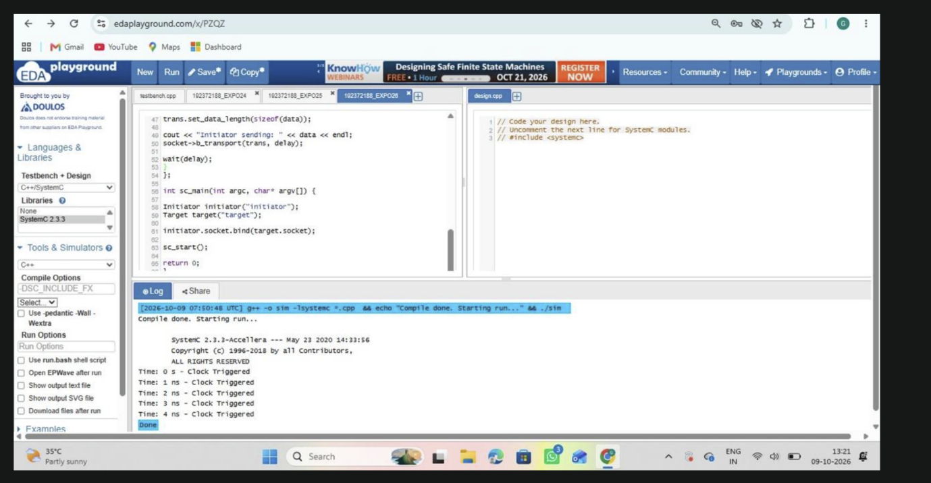

RESULT:
Thus the Transaction-Level Model using Initiator and Target modules was successfully
implemented and simulated using SystemC.

Experiment : 27
BINARY SEMAPHORE IN SYSTEMC
AIM:
To implement and simulate a Binary Semaphore using SystemC for task
synchronization.

PROGRAM:
#include <systemc.h>

SC_MODULE(binary_semaphore) {

int sem;
sc_event ev;

void task1() {
while(true) {
wait(1, SC_SEC);

if(sem == 1) {

sem = 0;
cout << "Task1 Entered Critical Section at " << sc_time_stamp() << endl;
wait(2, SC_SEC);
sem = 1;
ev.notify();
}
else {
wait(ev);
}
}
}

void task2() {
while(true) {
wait(2, SC_SEC);

if(sem == 1) {
sem = 0;
cout << "Task2 Entered Critical Section at " << sc_time_stamp() << endl;
wait(1, SC_SEC);
sem = 1;
ev.notify();
}
else {
wait(ev);
}
}
}

SC_CTOR(binary_semaphore) {
sem = 1;
SC_THREAD(task1);
SC_THREAD(task2);
}

};

int sc_main(int argc, char* argv[]) {
binary_semaphore obj("Binary_Semaphore");
sc_start(10, SC_SEC);
return 0;
}

OUTPUT:
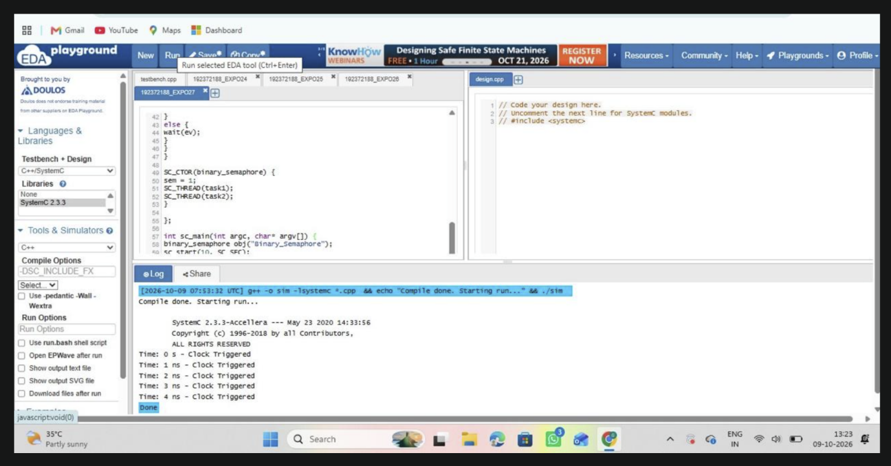

RESULT:
Thus the Binary Semaphore was created using SystemC and verified.

Experiment : 28

COUNTING SEMAPHORE IN SYSTEMC
AIM:
To implement Counting Semaphore allowing multiple resource access.

PROGRAM:
#include <systemc.h>

SC_MODULE(counting_semaphore) {

int sem;

void task() {
while(true) {
wait(1, SC_SEC);

if(sem > 0) {
sem--;
cout << "Task Accessing Resource at "
<< sc_time_stamp()
<< " Remaining: " << sem << endl;

wait(2, SC_SEC);
sem++;
}

}
}

SC_CTOR(counting_semaphore) {
sem = 2;
SC_THREAD(task);
SC_THREAD(task);
SC_THREAD(task);
}
};

int sc_main(int argc, char* argv[]) {
counting_semaphore obj("Counting");
sc_start(10, SC_SEC);
return 0;
}

OUTPUT:
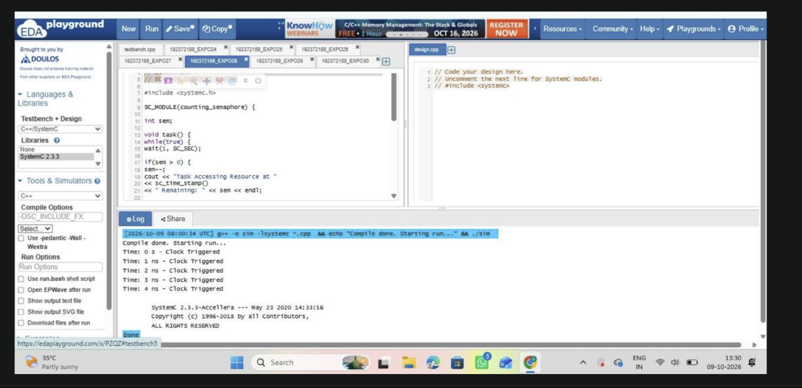
RESULT:
Thus the Counting Semaphore was created using SystemC and verified

Experiment : 29
PRIORITY-BASED INTERRUPT HANDLING
AIM:
To model priority-based interrupt servicing.

PROGRAM:
#include <systemc.h>

SC_MODULE(priority_interrupt) {

sc_event low_int, high_int;

void low_ISR() {
while(true) {
wait(low_int);
cout << "Low Priority Interrupt at "
<< sc_time_stamp() << endl;
wait(3, SC_SEC);
}
}

void high_ISR() {
while(true) {
wait(high_int);
cout << "High Priority Interrupt at "

<< sc_time_stamp() << endl;
wait(1, SC_SEC);
}
}

void generator() {
wait(1, SC_SEC);
low_int.notify();

wait(1, SC_SEC);
high_int.notify();
}

SC_CTOR(priority_interrupt) {
SC_THREAD(low_ISR);
SC_THREAD(high_ISR);
SC_THREAD(generator);
}
};

int sc_main(int argc, char* argv[]) {
priority_interrupt obj("Priority_INT");
sc_start(10, SC_SEC);
return 0;
}

OUTPUT : 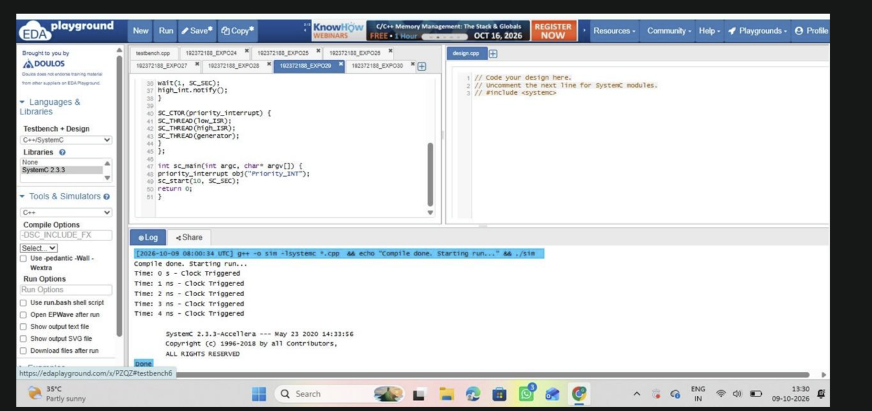
RESULT:
Thus the Priority based Interrupt handling was executed using SystemC and verified.

Experiment : 30
RTOS TASK SCHEDULING
AIM:
To simulate Round-Robin scheduling.

PROGRAM:
#include <systemc.h>
SC_MODULE(rtos_scheduler) {
void task1() {
while(true) {
cout << "Task1 Running at "
<< sc_time_stamp() << endl;
wait(1, SC_SEC);
}
}
void task2() {
while(true) {
cout << "Task2 Running at "
<< sc_time_stamp() << endl;
wait(1, SC_SEC);
}
}
SC_CTOR(rtos_scheduler) {
SC_THREAD(task1);
SC_THREAD(task2);
}
};

int sc_main(int argc, char* argv[]) {
rtos_scheduler obj("Scheduler");
sc_start(6, SC_SEC);
return 0;
}
OUTPUT : 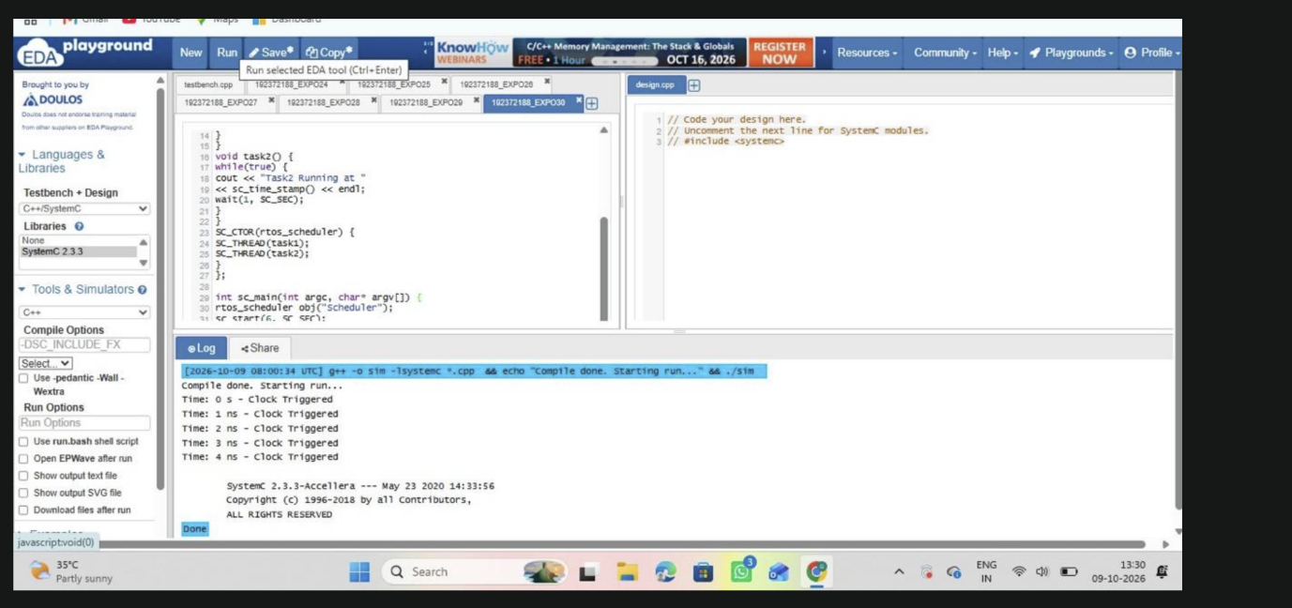
RESULT:
Thus the Round-Robin scheduling was executed using SystemC and verified.

